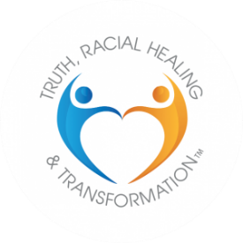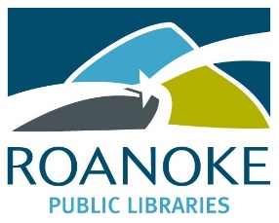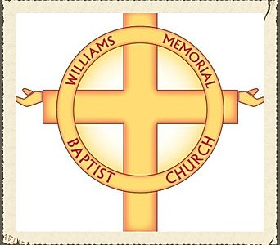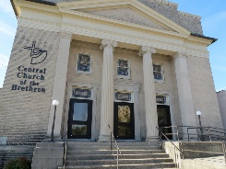

Please join us for A
Special Event Celebrating
CHANGING THE NARRATIVE
with
A Ritual of Prayer and Healing
Sunday, January 19 2019
At 3 pm
GAINSBORO LIBRARY
15 Patton Ave NW
Roanoke 24016

