PRIORTIES GOING FORWARD  #1 COMMUNITY GATHERINGS  IN DIVERSE NEIGHBORHOODS  FOR YOUTH  IN CHURCHES  BOTH LARGE & SMALL GROUPS  STUDY CIRCLES  NEIGHBORHOOD TOURS  FESTIVALS | 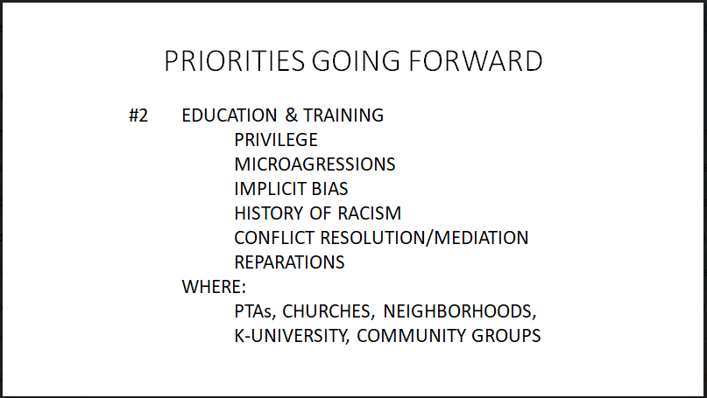
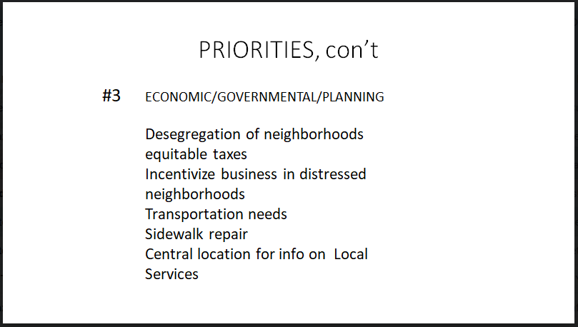 | PRIORTIES, CON’T  #4 INDIVIDUAL  ADVOCACY  RAISE A VOICE TO COUNTER INEQUITY  ENGAGE IN DIFFERENT CONVERSATIONS  VOTE  BE AWARE OF SOCAL JUSTICE ISSUES  “STAY WOLE”
 roanokevalleypointsofdivesity@gmail.com

